Preyasi Gaur

705704939

Problem Set 4

Math

1 Adaboost

1. 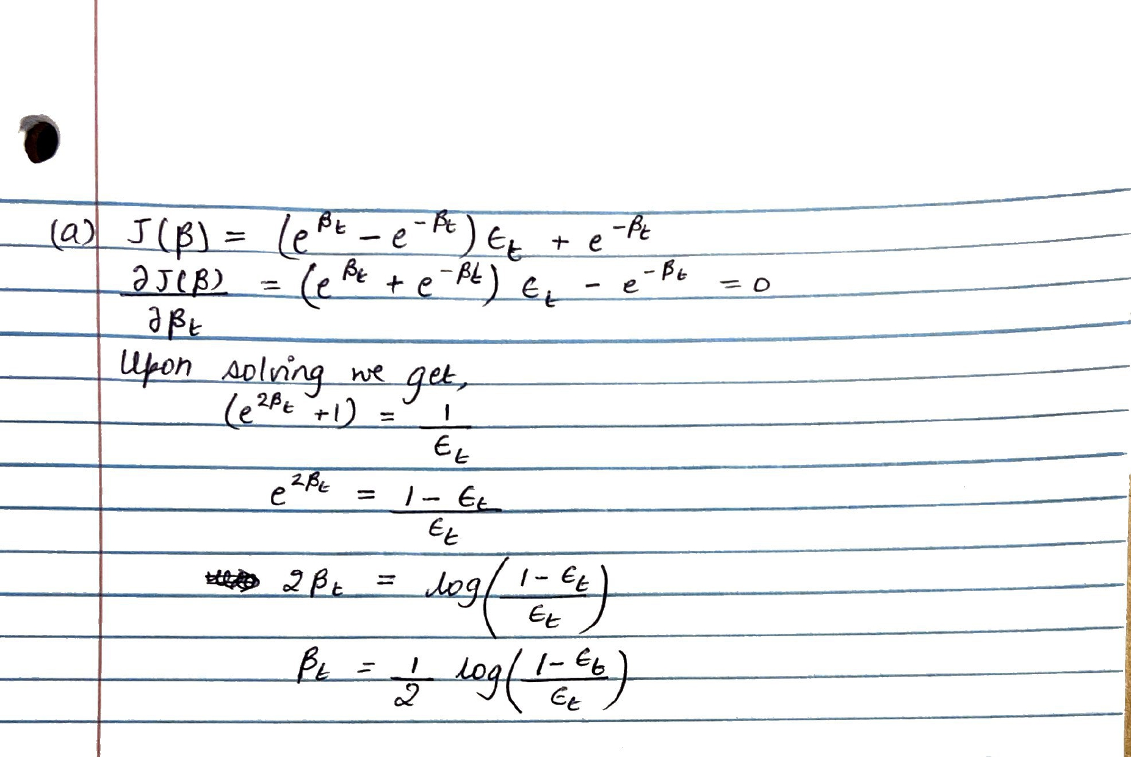

2 K-means for single dimensional data

1. The optimal clustering for this data is:

The corresponding value of the objective:

1. The suboptimal cluster assignment is:

The corresponding value of the objective:

When we run Lloyd’s on this configuration, the new cluster assignment will be

3 Gaussian Mixture Models

1. 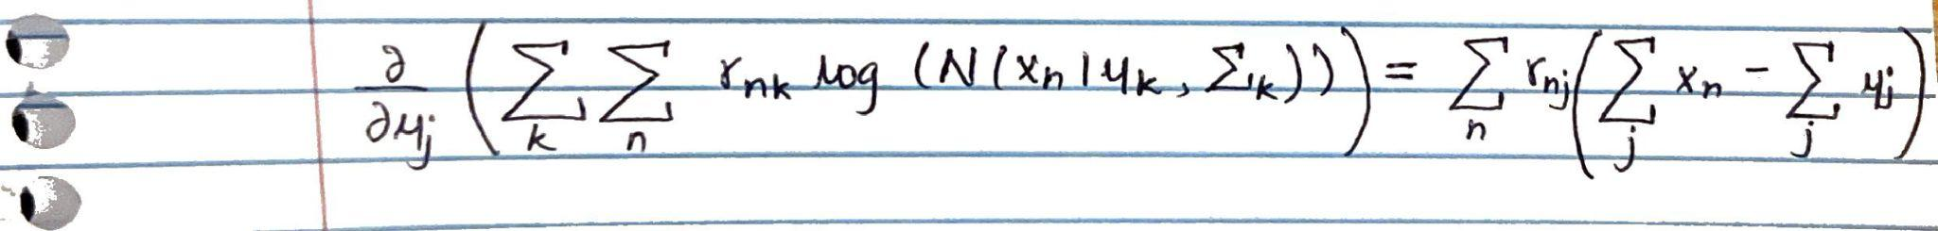
2. 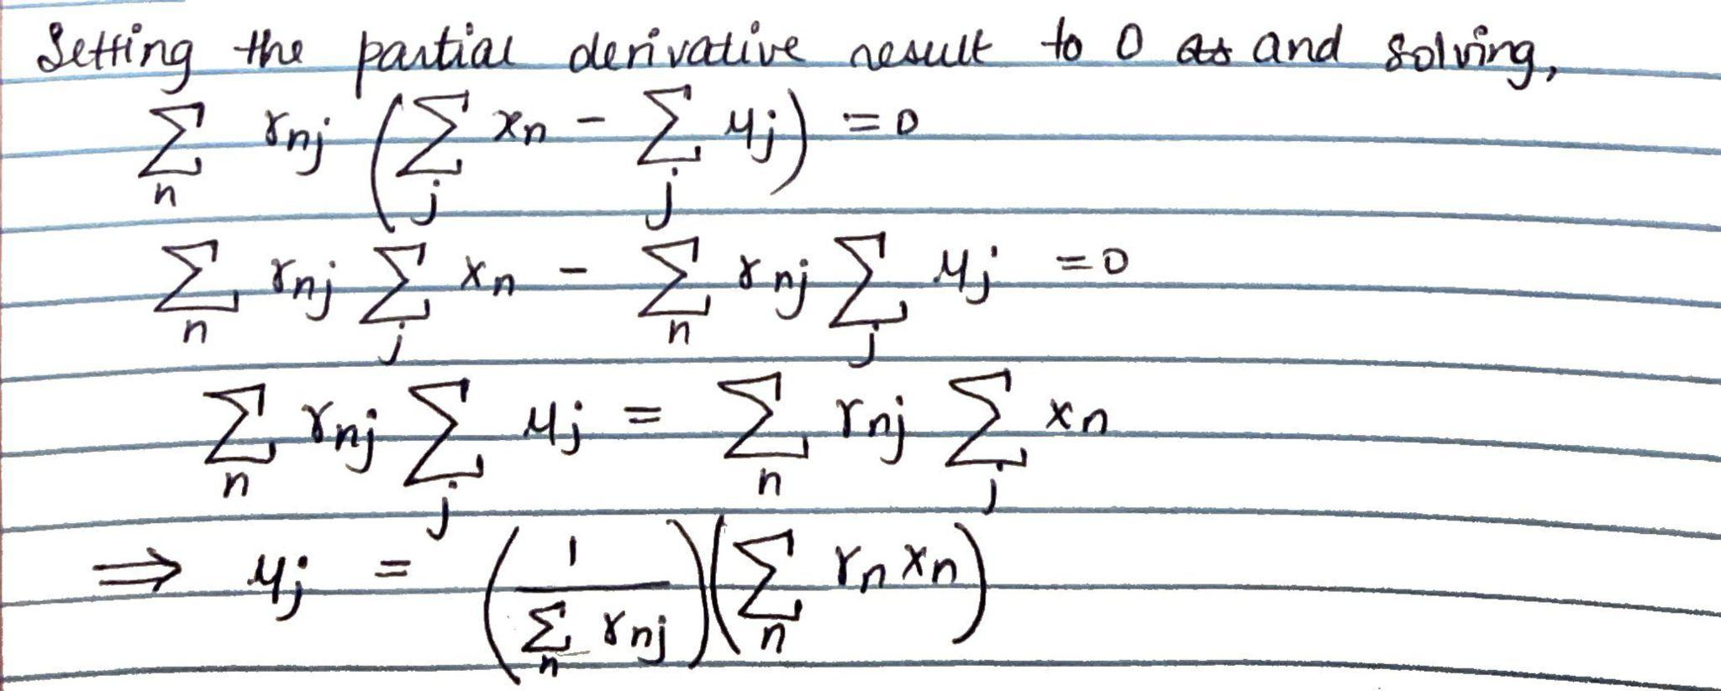
3. 